ASSIGNMENT 04

**Prepared By: ARM. Afrih**

**Student Id: TED/240063R**

**Build an Authentication System with React**

Contents

1. Login Page 3

2. Login Invalid Message 3

3. Code - Home 4

4. Authentication code 4

5. Protection Route code 5

6. App.jsx code 6

**Table of Figure**

Figure 1Login Page 3

Figure 2 Login Invalid Message 3

Figure 3 Home Page 4

Figure 4Authentication code 1 4

Figure 5 Authentication code 2 5

Figure 6 Protection Route 5

Figure 7 App.jsx 6

# 1. Login Page

Figure Login Page

# 2. Login Invalid Message

Figure Login Invalid Message

.

# 3. Code - Home

Figure Home Page

# 4. Authentication code

Figure Authentication code 1

Figure Authentication code 2

# 5. Protection Route code

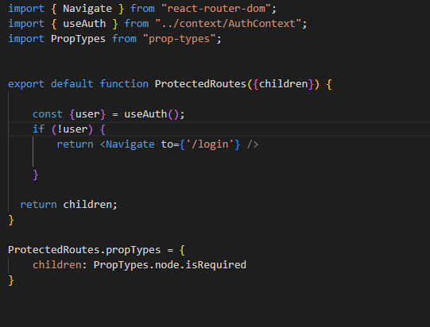

Figure Protection Route

# 6. App.jsx code

Figure App.jsx